**EN3160 - Image Processing and Machine Vision**

**Assignment 1 - Intensity Transformations and Neighborhood Filtering**

**Name :** A.A.H. Pramuditha

**Index No. :** 200476P

**GitHub Link :** [**hashirupramuditha/EN3160-Image-Processing-and-Machine-Vision (github.com)**](https://github.com/hashirupramuditha/EN3160-Image-Processing-and-Machine-Vision/tree/main)

Question 1: Intensity Transformation

Question 2: Intensity Transformation for a Brain Proton Density Image

Here, two linear transformations were used to separately emphasize the white and gray matter from the original image, and the threshold values were chosen using the trial-and-error method (trying various threshold values until the white and gray matter are significantly emphasized). Different values between 0-255 were first chosen to isolate the desired color range, after which the undesirable linear region was cut. This process began with a straightforward unity transformation.

* White Matter Region : 175 – 255
* Gray Matter Region : 138 – 180

Question 3: Gamma Correction

After trying different values, 0.78 is selected as the gamma value to apply gamma correction for the L plane, which is depicted in red color in the histograms.

Question 4: Increasing the Vibrance of a Photograph by Intensity Transformation

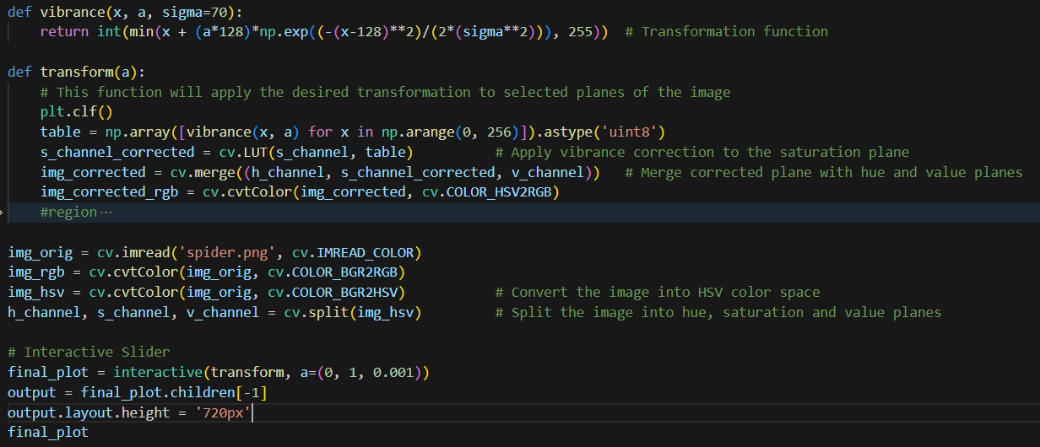

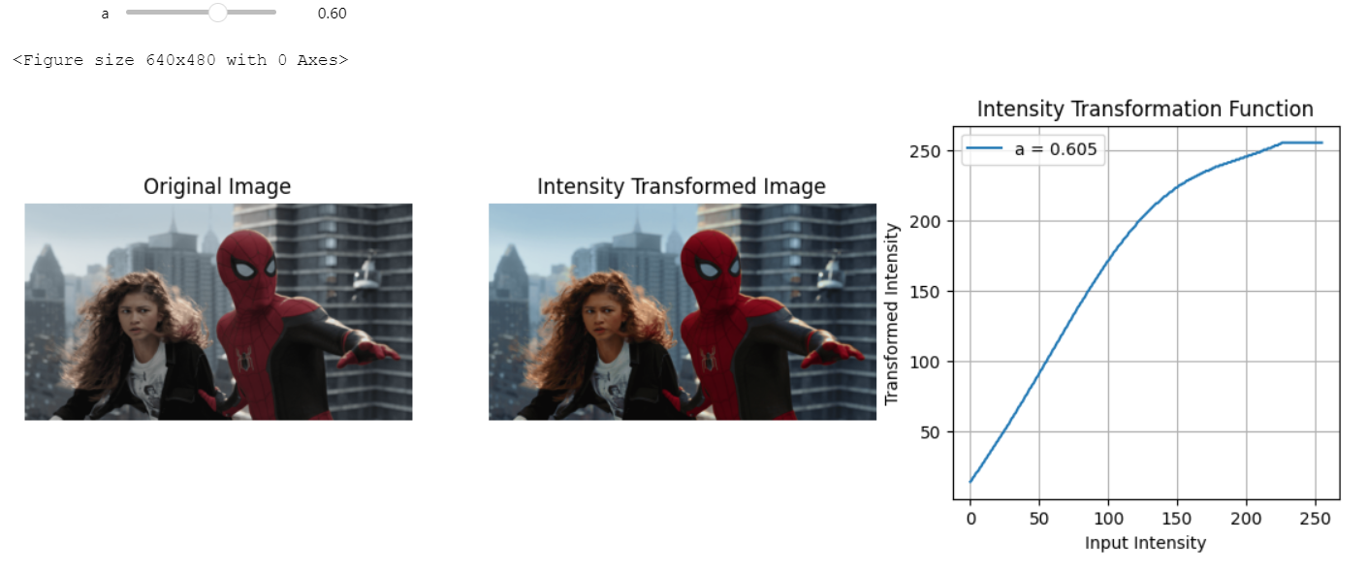

A visually pleasing output can be obtained when the value of “a” is in the range of 0.55 – 0.7.

Question 5: Histogram Equalization

In the custom equalization method, the histogram of the image is computed, followed by calculation and normalization of the CDF. Intensity values are then mapped to the 0-255 range. Then the new intensities are included in the table and the table will be reshaped into the shape of the original image. However, this custom method may yield different results from OpenCV's built-in histogram equalization function (cv.equalizeHist()).

Question 6: Histogram Equalization to Make Histogram Equalized Foreground

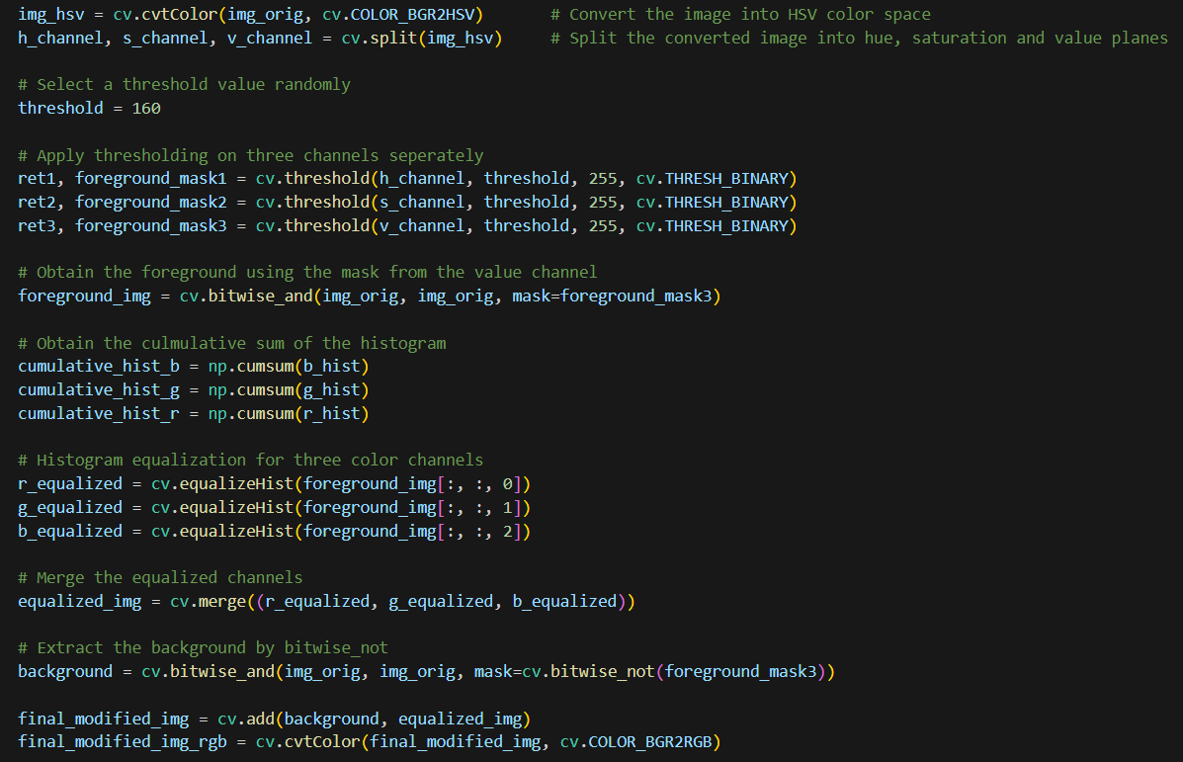

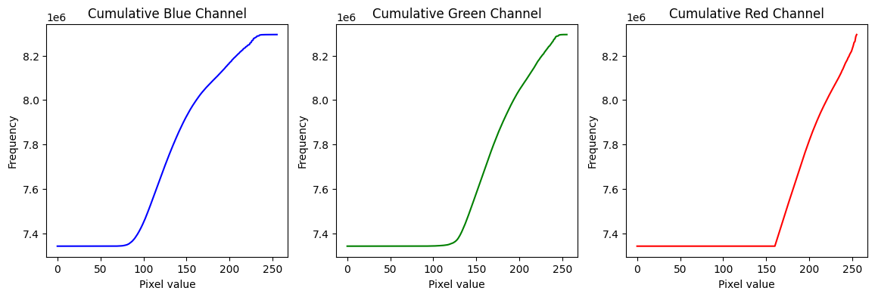

The threshold value for the above task was selected as 160 randomly.

Question 7: Sobel Filtering

Two kernels were added to the custom method to carry out the convolution with the image in both the horizontal and vertical axes. From the generated horizontal and vertical gradient images, it then determines the gradient's magnitude.

Although the filter2D() function is utilized in this case, the convolution of two kernels was accomplished in two steps. First, a row vector and a column vector were created from the supplied kernel. We can convolution with these row and column vectors individually thanks to the associativity of convolution.

Question 8: Zooming Images

1. Nearest Neighborhood Method

1. Bilinear Interpolation Method

For the Nearest-Neighborhood Method, SSD value is 180381523, and for the bilinear interpolation method, SSD value is 2031930775.

Question 9: Image Segmentation

Here we create the enhanced image by combining foreground image with a gaussian blurred background. When combining these two images, these gaussian blurred pixels will mix with the pixels representing flower’s edge which contain high contrast information. When these pixels are mixed, the transition region from the flower edge to the background of the image becomes less distinct and less noticeable. That’s why the transition region appears quite dark in the enhanced image.